**TEAM ID: PNT2022TMID20093**

**PROJECT TITLE: IOT BASED SMART CROP PROTECTION SYSTEM FOR AGRICULTURE**

Interfacing with Node-RED

Node-RED based browser editor and IBM Cloud have been made major use of to implement this project. In order to access IBM Cloud, one must register and create an account first. The browser-based editor allows you to drag and drop nodes which can be wired together and deployed by a single click. A Node-RED service is created using the IBM Cloud platform in order to connect the IBM IoT sensors and also to store the data in the cloud. The Node-RED app is created and the Continuous Delivery feature is enabled once the app has been deployed into the Cloud Foundry space. It is essential to create an IBM Cloud API key to be able access one’s resources. After the Node-RED application has been created, the app URL is created which links the editor to IBM.

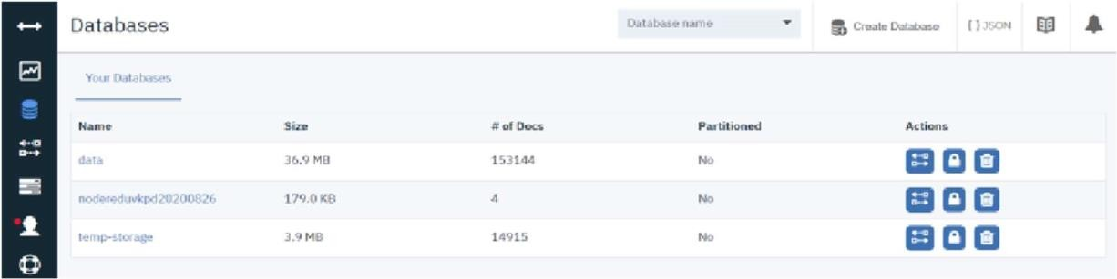

Obtaining sensor data on Node-RED through MQTT and IBM IoT

Message Queuing Telemetry Transport (MQTT) is a communication protocol of the publish/subscribe type, which allows a network of protocol devices to publish data to a broker. The broker acts as a mediator to communicate between devices. Every device can “subscribe” to a certain topic and when a message is published by another client on the subscribed topic, the message is forwarded by the broker to the client that subscribed to that specific topic. Due to its lightweight, efficiency and bidirectional capabilities, MQTT significantly increases the capacity of data that can be monitored. It plays an important role of communication in IoT projects by facilitating the connections between devices, servers, and applications.

Once the sensor data has been computed and regulated when necessary, MQTT acts as a gateway and transmits data to the load (the actuators), through Wi-Fi.

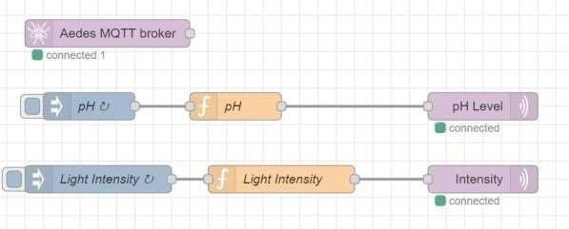

Automating the processes using Node-RED

The optimal ranges of different parameters required for the healthy growth of Lettuce are:

* Temperature -18.3 degree Celsius to 23 degree Celsius
* Humidity - 50% to 70%
* Soil pH - 6 to 7
* Light intensity - 400 μmol/m2s to 600 μmol/m2s
* Machine overheating temperature - over 70 degree Celsius

Integration with Mobile Application

The mobile application has been developed with the use of Flutter SDK. This has allowed us to be really flexible on our app. With flutter, we were able to use the BloC architecture to create our authentication page. Upon starting the app, this would be the first screen (unless you logged in previously). This involved the use of Firebase to store the credentials of the user as well as storing the authentication token locally. After authentication, the user is directed to the home screen, where all the stats of the different sensors are shown. To always show the latest updated readings, we chose to use a WebView package that directly gets data from the Node-RED dashboard. This application also has an option to hide the data that we receive while the application is open. It also has a logout functionality that sends the user back to the authentication screen.

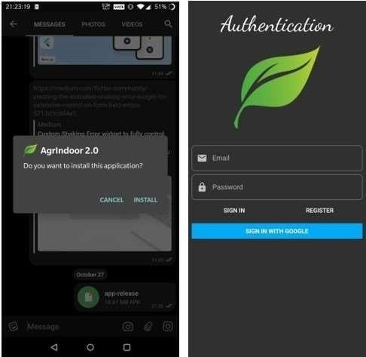

Mobile Application Install and Authentication page

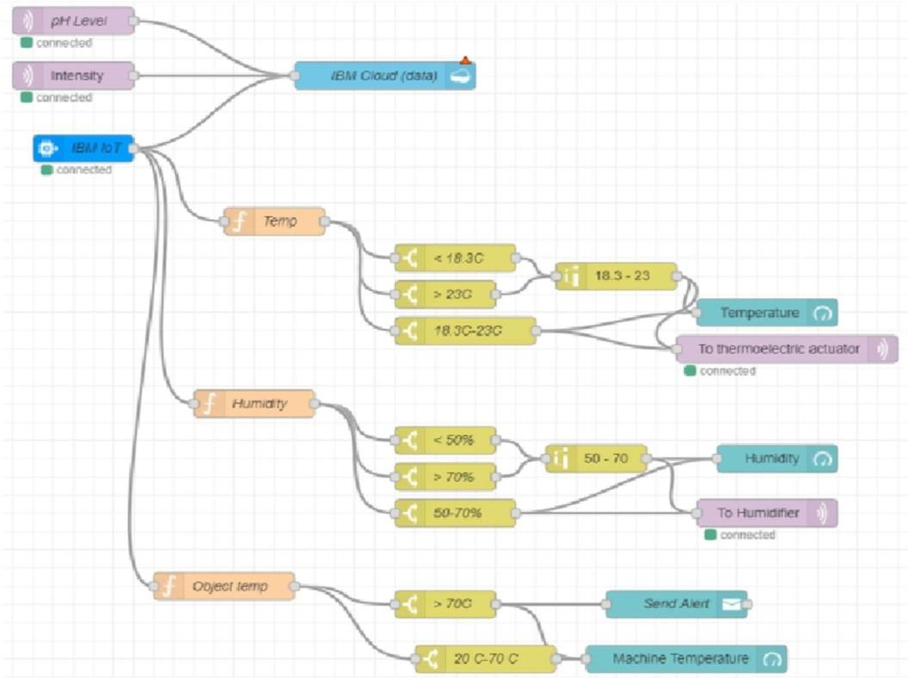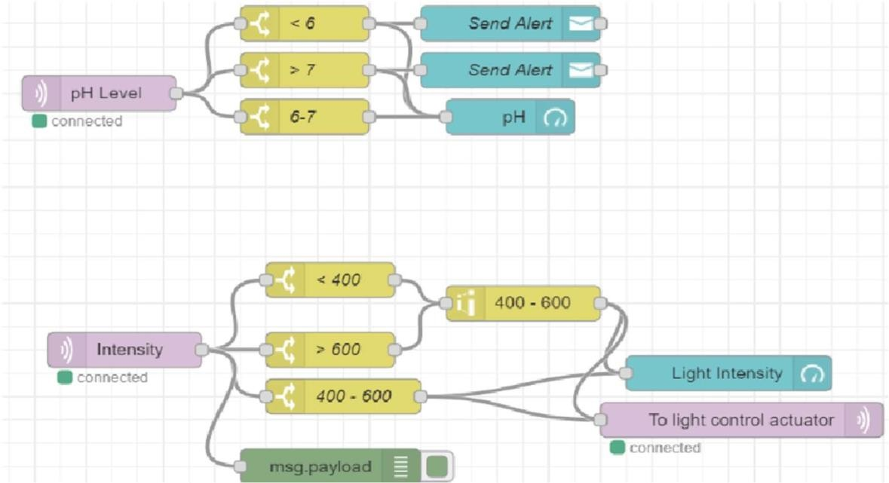

Node-RED Flow